CSR Certificate

1. Log on to below mentioned myDamco servers:

* Production – SCRBFLXDKCPH222

SCRBFLXDKCPH223

* Pre-Production ­- SCRBFLXDKCPH100

SCRBFLXDKCPH101

* Test - SCRBFLXDKCPH 122

SCRBFLXDKCPH 001

2. open IIS in server.

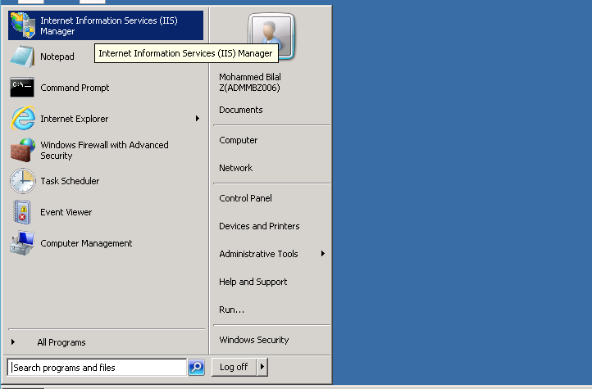

3. On IIS home page, scroll down to double click on server certificates under IIS.

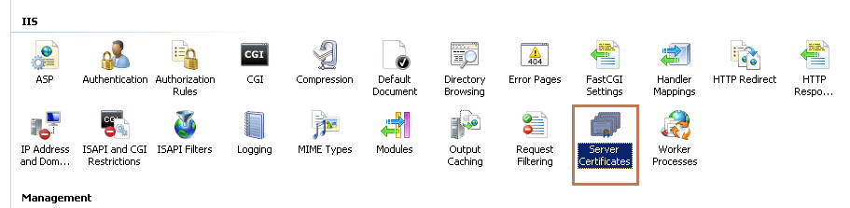

4. On the top right corner of the window click on “Create certificate request”

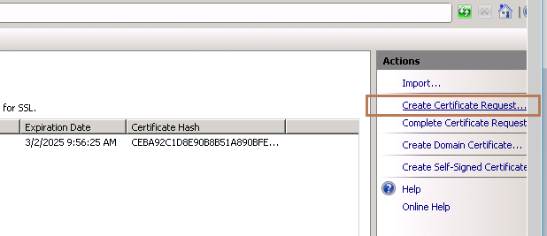

5. Fill in the certificate request form as details given below. Below mentioned Screenshot is only for reference. After filling the below given details, click on Next.

**Common Name**:

Production - Portal.damco.com

PreProduction - PreProduction-portal.damco.com

Test - Integration-portal.damco.com

**Organization** : Damco International B.V

**Organizational** Unit : Damco IT

**City/Locality** : Den Hag

**State/Province** : Den Hag

**Country/ Region** : NIL

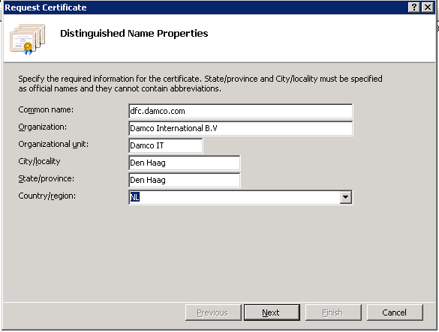

6. Select the RSA algorithm and the bit length of 2048 as shown below. And click next.

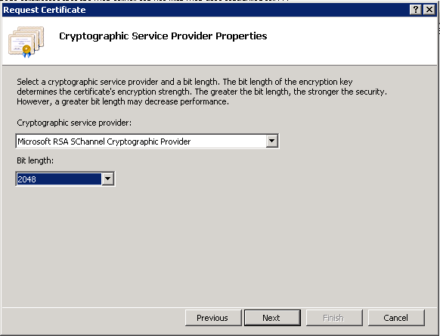

7. Mention the valid path on the server( you may create your own folder ) and mention the file name to save the CSR code in. and then click finish.

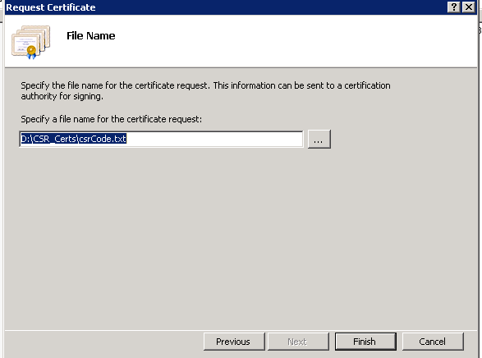

8. Navigate to the path above to get your CSR code in the file.



